Day 20
Sprint 1 Submission
Name: Mriganka Patra
Emp ID: 2415820
Email: Mriganka.Patra@cognizant.com

Task:
Write and execute manual test cases for SharePoint forms.

Manual Test Cases:
Test Case 2: Data Type Validation - Invalid Input
Description: Verify that the form correctly validates input for specific data types (e.g., names, gender) and displays error messages for invalid entries.

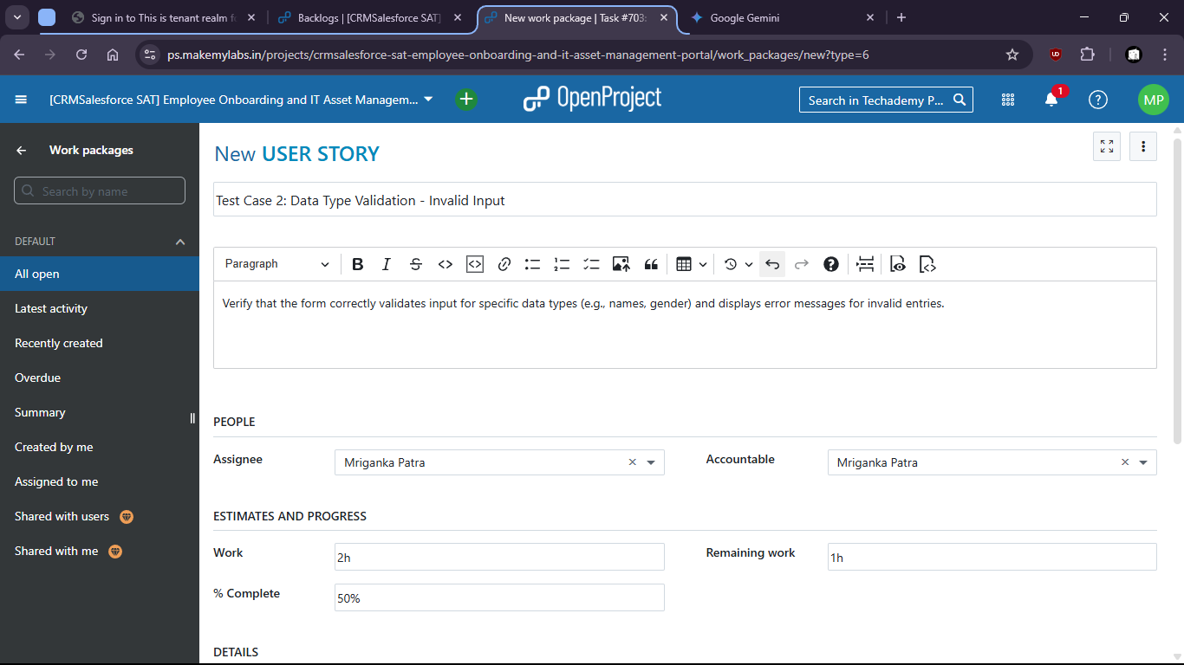

There is no option to put invalid data and submit wrong format.

